**Review 1**

**Book Renting Service**

**Abstract**

The project entitles "Online Book Rental Portal" is a very effective, feasible online portal that facilitates the readers to read the books and magazines on rent reliably. If a reader wants to read a book, he/she has to purchase the book, which is not worth it for most users, especially for those who want to refer to only a part of the specific book, or does not want to keep the book after purchase or they can go to the library to lend a book where firstly they have to be a member and have to follow the library rules and regulations - like to return the book at the specified date that is given by the library. There is not much flexibility with the library management system and many places do not even have libraries and many of them are not very well maintained. So, a lot of time and money gets wasted on these. But with our application, the situation becomes very easy. The person which is having the book can give the book on rent for some days at a reasonable rent and can gain money and on the contrary, those who want to rent a book can communicate with the book giver through our portal. So, in general, our online book rental system will allow a user to rent a book online from the website. Once a book is rented it is no longer available to rent again by other users until the book is returned. The book which has already been rented will show the name of the renter and the date until when it is rented for the main objective of the project is to create an online book rental site that allows users to search and rent a book online based on title, author and subject. Using this Website, the user can rent a book online instead of going out to a book store and library spending a lot of their time.

**Problem Statement**

If a reader wants to read a book, he/she has to purchase the book, where they have to give much money or they can go to the library to lend a book where firstly they have to be a member and have to follow the library rules and regulations - like to return the book at the specified date that is given by the library. So, a lot of time and money gets wasted on these. With our portal situation becomes very easy. The person which is having the book can give the book on rent for some days at a reasonable rent and can gain money and on the contrary, those who want to rent a book can communicate with the book giver through our portal. So, in general, our online book rental system will allow a user to rent a book online from the website.

**Reason**

The main leverage of this project is the fact that many people like collecting books, including ourselves whereas many people don’t have access to books for cheap, or do not particularly want to read the entire book but only a segment of that particular book. Also, many people like to read stuff in hardcopy format instead of softcopies. These two groups of people can massively benefit each other through the use of an application such as ours. Borrowing and renting such books makes a lot of sense to us as in most cases, after we read a particular book, we don’t refer to most books again very often and they just accommodate with not a lot of use. Through our application, people can make their book available for rent for other people to borrow for some time which gives the renter a passive income source and the borrower a cheap alternative to read from a book instead of buying a new book every time. It also helps to create a community of people having similar interests.

**Process Flow Diagram**

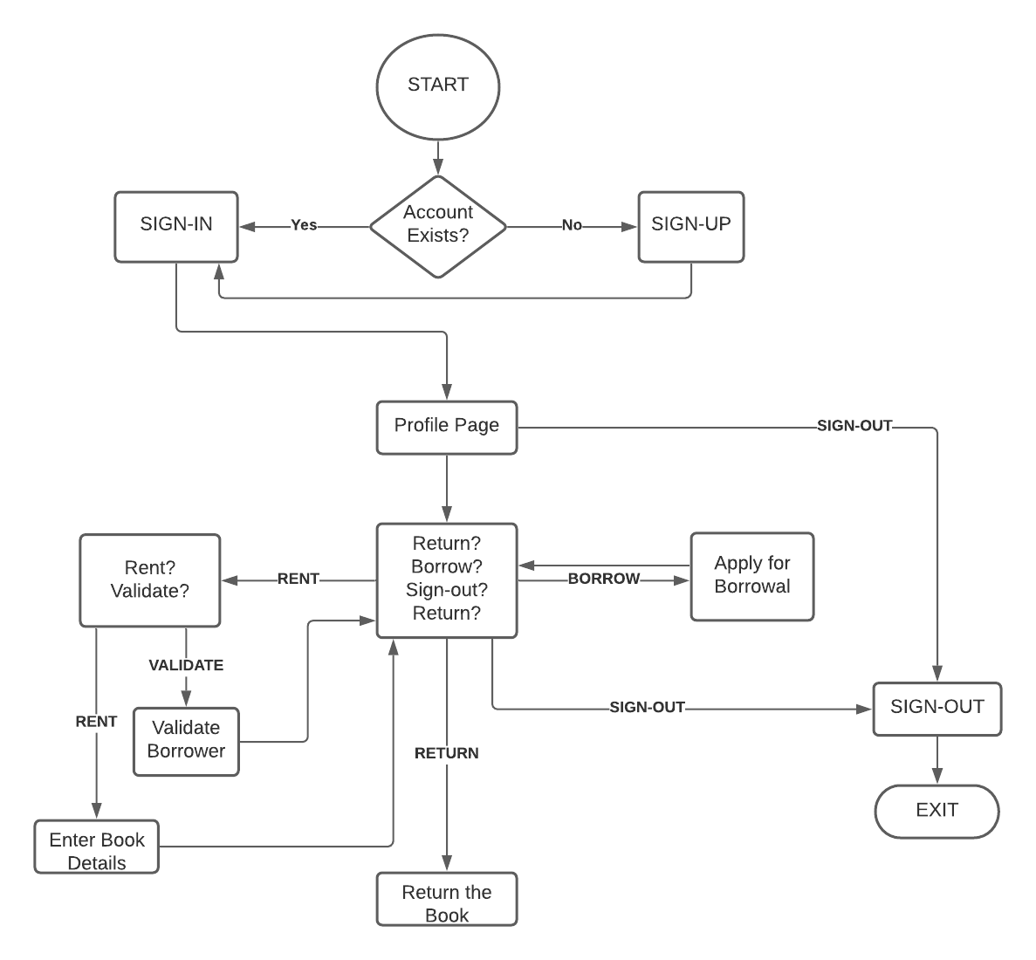

**Modules**

Requirements and Frameworks: HTML, CSS, JavaScript, Node.js, Passport.js, Express.js, MongoDB (mongoose.js)

**Database model creation**

A database model shows the logical structure of a database, including the relationships and constraints that determine how data can be stored and accessed. Individual database models are designed based on the rules and concepts of whichever broader data model the designers adopt. Most data models can be represented by an accompanying database diagram.

**Sign-in, Sign-up, Sign-out**

*Sign-in*

Sign-in is for the session creation

*Sign-up*

Sign-up is for the registration of customers & lenders.

*Sign-out*

Sign-out is for ending an already existed session

**User profile management**

The User Profile Management feature provides central management for user-specific data and settings stored in the users' model.

**Book rental system**

Users can make the books available for rent from here for other people to borrow.

**Book borrower system**

Users can browse the books and send a borrow request.

**Book return system**

This is where the borrower will return the book and pay if any due is there.

**Prototype Design**

On the home page, the user has to login into their account. If they do not have an account then the user has to sign up to the portal. After signing up, the user is redirected to the sign-in page where the user credentials are verified. If the credentials are correct, the website creates a session cookie to keep the user signed in and prevents access to sign-in and sign-up pages to prevent malicious users from using their generated cookie to access other’s accounts. Also, a middleware is configured to check if the user is trying to bypass login to access restricted pages and if they are; the user is redirected to the login page to log in with their credentials and session cookie. After signing in, the user can see his/her profile. Users can update their profiles here. From here user gets an option to perform one of many activities. Users can choose to make a book available for rent, borrow books, return the borrowed books, or either sign out.

If the user chooses to check the rental system, he will be redirected to another page that is composed of two components, the book rental system, and the history of previously rented books. In the book rental system, there will be a form in which details of the book which the user wants to give away for rent will be submitted and the book will be made available in the borrow section of the application. The history section of the page is mainly used for two tasks. Firstly, to show details of all transactions. Secondly, if any other user sends a request to borrow the book, the renter gets to choose if he wants to lend the book to that particular user or not. The book transaction gets through the initiation state only after the borrower is validated by the renter.

On the borrower section, the user can send a borrow request to the vendor of the book and browse through all the books which are up for borrowing. The restriction is that the user cannot borrow the book which he made available to borrow.

On the book return section, users can see the list of all the books he/she had ever borrowed from the portal along with the option to return the books he currently has not returned to its owner. For the transaction to be safely finalized, we will be implementing an OTP-like system. Whenever a book is made available for rent, a random number is also generated as an OTP which only the renter has access to. For the borrower to be able to complete the transaction, he has to enter that OTP for confirmation which the vendor will tell him/her. If the OTPs don’t match, the transaction won’t close. If the OTPs match, it can be deduced that both the borrower and vendor approve the completion of a transaction and therefore can be terminated.

The user can also manually sign out which expires the session cookie, otherwise, the session cookie will automatically expire after some time, making the user log in again for security reasons.